import numpy as np
import matplotlib.pyplot as plt
from functools import partial
from sklearn.gaussian_process import GaussianProcessRegressor
from sklearn.gaussian_process.kernels import Matern

%matplotlib inline

!pip install modal
from modAL.models import BayesianOptimizer
from modAL.acquisition import optimizer_EI, max_EI

import numpy as np

# SIMILAR DATOS
X = np.linspace(0, 20, 1000).reshape(-1, 1)
y = np.sin(X)/2 - ((10 - X)**2)/50 + 2
with plt.style.context('seaborn-white'):
plt.figure(figsize=(10, 5))
plt.plot(X, y, c='k', linewidth=6)
plt.title('The function to be optimized')
plt.show()

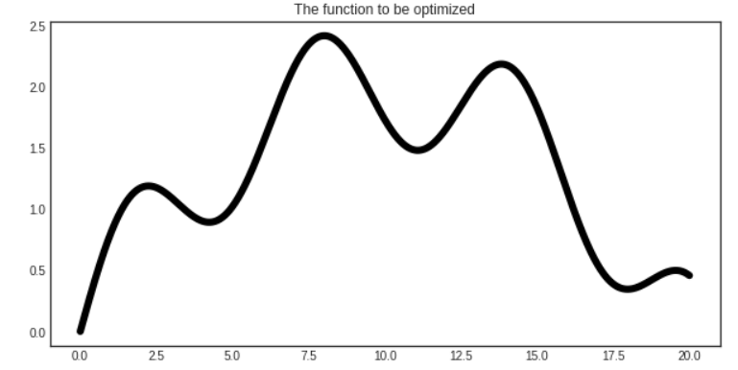
# assembling initial training set
X_initial, y_initial = X[150].reshape(1, -1), y[150].reshape(1, -1)

# defining the kernel for the Gaussian process
kernel = Matern(length_scale=1.0)
regressor = GaussianProcessRegressor(kernel=kernel)

# initializing the optimizer
optimizer = BayesianOptimizer(
estimator=regressor,
X_training=X_initial,
y_training=y_initial,
query_strategy=max_EI
)

# Bayesian optimization
for n_query in range(5):
query_idx, query_inst = optimizer.query(X)
optimizer.teach(X[query_idx].reshape(1, -1), y[query_idx].reshape(1, -1))

y_pred, y_std = optimizer.predict(X, return_std=True)
y_pred, y_std = y_pred.ravel(), y_std.ravel()

with plt.style.context('seaborn-white'):

X_max, y_max = optimizer.get_max()

plt.figure(figsize=(10, 5))
plt.scatter(optimizer.X_training, optimizer.y_training, c='k', s=50, label='Queried')
plt.scatter(X_max, y_max, s=100, c='r', label='Current optimum')

plt.plot(X.ravel(), y, c='k', linewidth=2, label='Function')
plt.plot(X.ravel(), y_pred, label='GP regressor')

plt.fill_between(X.ravel(), y_pred - y_std, y_pred + y_std, alpha=0.5)
plt.title('First five queries of Bayesian optimization')
plt.legend()
plt.show()

